**USER MANUAL: FLAPP + ARDUINO SENSORS**

1 INTRODUCTION TO FLAPP’S ECOSYSTEM 2

2 HOW TO SET UP YOUR OWN SENSORS 3

2.1 Electroconductivity (EC) / pH sensor 3

2.1.1 Material 3

2.1.2 Set up the sensor 3

2.2 Pressure sensor 4

2.2.1 Material 4

2.2.2 Set up the sensor 5

2.3 Temperature sensor 5

2.3.1 Material 5

2.3.2 Set up the sensor 6

2.4 Weight sensor 7

2.4.1 Material 7

2.4.2 Set up the sensor 7

3 HOW TO UPLOAD SENSOR CODES WITH ARDUINO IDE 9

4 HOW TO INSTALL FLAPP APP IN ANDROID 10

5 HOW TO USE THE APP 11

# INTRODUCTION TO FLAPP’S ECOSYSTEM

**Can you imagine having complete control over your experiments with a low-cost sensor system built by yourself?**

With this manual, you can not only collect accurate and customized data but also save money and learn essential tech skills while building tools tailored to your needs. This manual will guide you step by step to create your own sensor system, from the basics to a functional design, enabling you to monitor, measure, and record all the information from your projects efficiently and professionally. Innovation is in your hands!

**What is FLAPP project about?**

This project brings technology to life by combining cutting-edge software and hardware to create a powerful system of sensors and actuators. Designed for real-time monitoring and control, it’s perfect for personalized projects. The goal? To deliver a dynamic, cost-effective, and user-friendly solution that empowers scientists and citizens alike with access to high-quality data. Whether you’re a researcher, hobbyist, or data enthusiast, this project puts innovation and precision at your fingertips.

Imatge que conté text, cable

Descripció generada automàticament

# HOW TO SET UP YOUR OWN SENSORS

As tools, you will need at least one cutter, screwdriver and pliers.

First of all, we will recommend you remove all the packaging to dispose of all the material without having to make stops when you start to assemble the different sensors.

[Click here to see all the videos of how to mount each sensor.](https://drive.google.com/drive/folders/1pJVmIqCvJQY8Tuv1QOb3zK2aEmzPpLRU?usp=sharing)

## Electroconductivity (EC) / pH sensor

### Material

Make sure you have all the material from the following table:

|  |  |  |
| --- | --- | --- |
| ESP32 | CONNECTION PLATE | ISOLATOR (optional) |
|  | KIT MINI PARA ARDUINO CON UNO R3 (10 COMPONENTES) |  |
| pH SENSOR | **EC SENSOR** | **CABLES** |
|  |  |  |

### Set up the sensor

1. Cut one side of the connection plate to fit the sensor into the box. [Video link.](https://drive.google.com/file/d/1Bdlu-jHQMHMchdUJ4w0qhpB6GFINbjRV/view?usp=sharing)
2. Follow the schema below to set up the sensor:

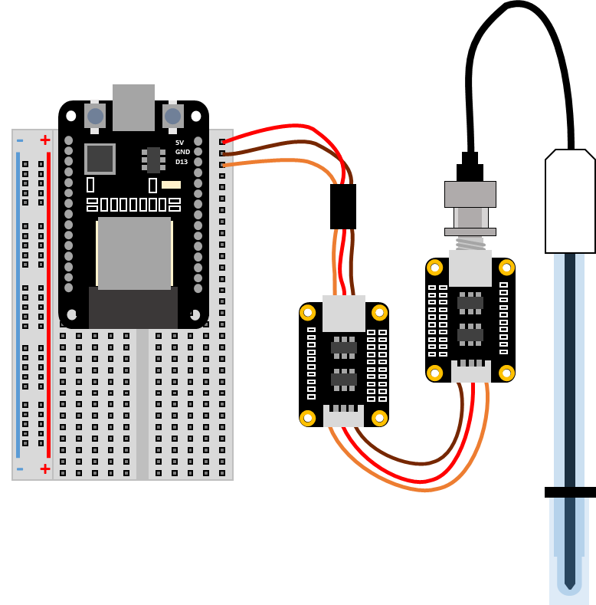

1. Connections needed are:

|  |  |  |
| --- | --- | --- |
| ESP32 pin | EC / pH Sensor Pin | Color in the scheme |
| +3.3v | Vcc (+) | Red |
| GND | GND (-) | Brown |
| 13 | Vout (A) | Orange |

## Pressure sensor

### Material

Make sure you have all the material from the following table:

|  |  |  |
| --- | --- | --- |
| ESP32 | CONNECTION PLATE | PRESSURE SENSOR |
| Imatge que conté electrònica, Component de circuit, Component electrònic, Component d'ordinador  Descripció generada automàticament | KIT MINI PARA ARDUINO CON UNO R3 (10 COMPONENTES) |  |

### Set up the sensor

1. Cut one side of the connection plate to fit the sensor into the box. [Video link.](https://drive.google.com/file/d/1Bdlu-jHQMHMchdUJ4w0qhpB6GFINbjRV/view?usp=sharing)
2. Follow the schema below to set up the sensor:

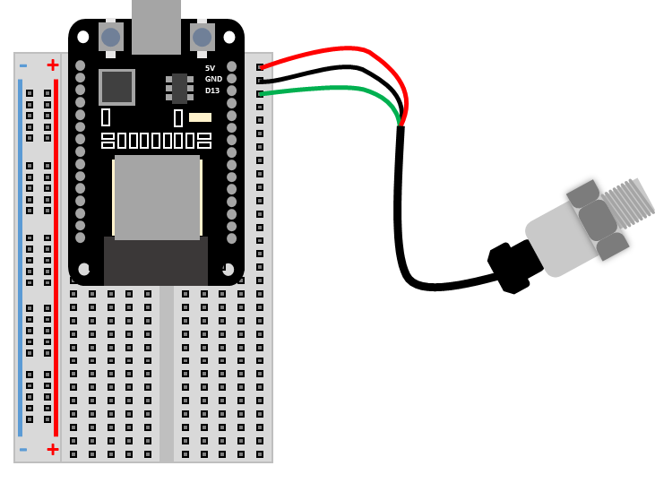

1. Connections needed are:

|  |  |  |
| --- | --- | --- |
| ESP32 pin | Pressure Sensor Pin | Color in the scheme |
| +3.3v | Vcc (+) | Red |
| GND | GND (-) | Black |
| 13 | Vout (A) | Green |

## Temperature sensor

### Material

Make sure you have all the material from the following table:

|  |  |  |  |
| --- | --- | --- | --- |
| ESP32 | CONNECTION PLATE | TEMPERATURE SENSOR | CABLES |
| Imatge que conté electrònica, Component de circuit, Component electrònic, Component d'ordinador  Descripció generada automàticament | KIT MINI PARA ARDUINO CON UNO R3 (10 COMPONENTES) |  |  |

### Set up the sensor

1. Cut one side of the connection plate to fit the sensor into the box. [Video link.](https://drive.google.com/file/d/1Bdlu-jHQMHMchdUJ4w0qhpB6GFINbjRV/view?usp=sharing)
2. Follow the schema below to set up the sensor:

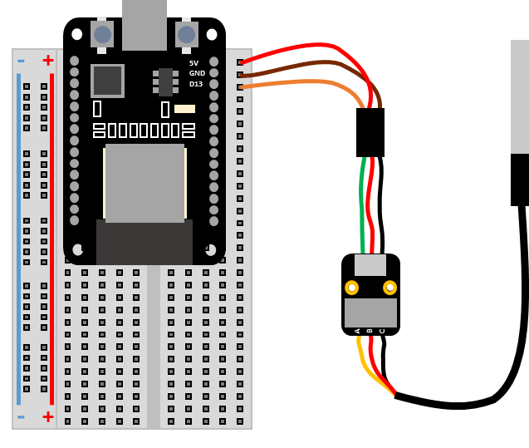

1. Connections needed are:

|  |  |  |
| --- | --- | --- |
| ESP32 pin | Pressure Sensor Pin | Color in the scheme |
| +3.3v | Vcc (+) | Red |
| GND | GND (-) | Brown |
| 13 | Vout (A) | Orange |

## Weight sensor

### Material

Make sure you have all the material from the following table:

|  |  |  |
| --- | --- | --- |
| ESP32 | CONNECTION PLATE | HC-05 MODULE |
| Imatge que conté electrònica, Component de circuit, Component electrònic, Component d'ordinador  Descripció generada automàticament | KIT MINI PARA ARDUINO CON UNO R3 (10 COMPONENTES) |  |
| RS232 MODULE | **CABLES** |  |
|  |  |  |

### Set up the sensor

1. Cut one side of the connection plate to fit the sensor into the box. [Video link.](https://drive.google.com/file/d/1Bdlu-jHQMHMchdUJ4w0qhpB6GFINbjRV/view?usp=sharing)
2. In this case, there are two possible options to set up the sensor: directly to the HC-05 module (a) or assembled on the connection plate (b):

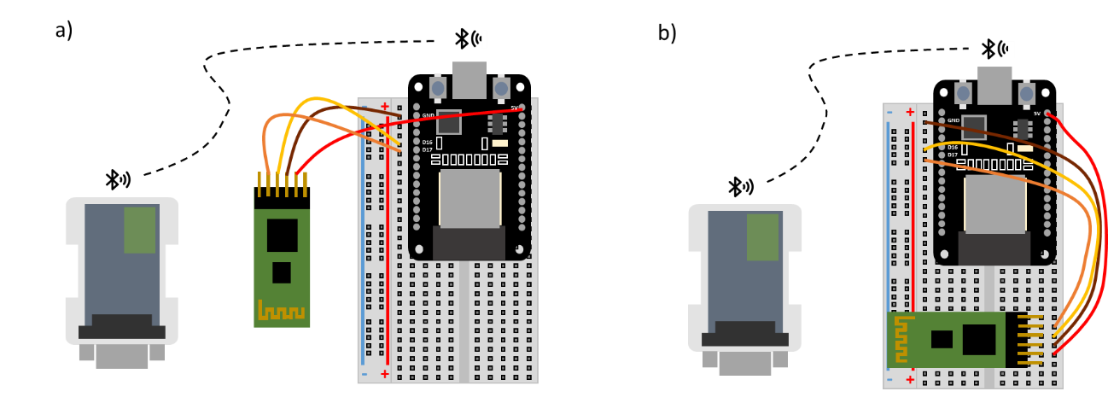

1. Connections needed are:

|  |  |  |
| --- | --- | --- |
| ESP32 pin | Pressure Sensor Pin | Color in the scheme |
| +5v | Vcc (+) | Red* (welded cable) |
| GND | GND (-) | Brown |
| 16 | TX | Yellow |
| 17 | RX | Orange |

# HOW TO UPLOAD SENSOR CODES WITH ARDUINO IDE

The following step is uploading the codes into each sensor. In this step you will need a computer.

1. [Download and install Arduino IDE](https://support.arduino.cc/hc/en-us/articles/360019833020-Download-and-install-Arduino-IDE)
2. [Install CH340 driver](https://sparks.gogo.co.nz/ch340.html)
3. Install [CP210x Universal Windows Driver](https://www.silabs.com/documents/public/software/CP210x_Universal_Windows_Driver.zip)
   1. Unzip the folder.
   2. Click on “*silabser*” with the right button.
   3. Install it.
4. Open Arduino IDE and accept all the drivers that appear.
5. [Install ESP32 board](https://randomnerdtutorials.com/installing-esp32-arduino-ide-2-0/) in Arduino IDE:
   1. Go to Install ESP32 Add-on in Arduino IDE.
   2. Follow the instructions.
   3. Install esp32 version **2.0.17.**
6. Refer to the main [github repository](https://github.com/nicolassaganias/flapp/tree/main) to download the codes.

Imatge que conté text, captura de pantalla, nombre, programari

Descripció generada automàticament

* 1. To download from the github page go to the upper right green section “CODE”and click“*download .zip file*”to download all the codes or copy/paste to your arduino IDE.
  2. Once downloaded, unzip it and go to “*/Firmware/ESP32_updated”*.
  3. Open the code you need and look for the folder named after the sensor you are going to use.
  4. Open that folder and double click the *.ino* file to open it with Arduino IDE app.

1. In Arduino IDE program, go to “*File/Preferences*” and in “*Sketchbook location*” put the directory of the recently downloaded folder (“*Flapp_main*”). Be careful when you refer to the folder “*Flapp_main*” because when you unzip it, it generates a new folder. You should see the *LIBRARIES* folder and refer to the main *FLAPP* folder.
2. Connect ESP32 board to the computer with micro usb cable.
3. Upload desired Code. [How to upload an arduino code?](https://support.arduino.cc/hc/en-us/articles/4733418441116-Upload-a-sketch-in-Arduino-IDE)
   1. Go to “*Select board*” and select the one related to your sensor (if you don’t know which one is, disconnect the sensor and you’ll see it).
   2. Search the “*ESP32 Dev Module*”:

Imatge que conté text, captura de pantalla, pantalla, programari

Descripció generada automàticament

* 1. Click “*OK*”
  2. Go to “*Sketch*” upper left corner and “*Upload*” (arrow button).

*FAQs:*

*Is the weight sensor not displaying data in the app?*

*Probably the HC-05 module is not pairing to the RS232 module correctly. If the red light inside RS232 and also in HC-05 module is blinking continuously and fast it means that they are looking for devices to connect and so, they are not paired. To solve this issue refer to the github main repository in the file named "Instructions for binding BT devices.md". Link below:*

[*https://github.com/nicolassaganias/flapp/blob/main/Instructions%20for%20binding%20%20BT%20devices.md*](https://github.com/nicolassaganias/flapp/blob/main/Instructions%20for%20binding%20%20BT%20devices.md)

# HOW TO INSTALL FLAPP APP IN ANDROID

Once you have your sensors assembled and with the code uploaded, the next step is installing the FLAPP app in your android device (apple is not yet available).

1. Install FLAPP app *(.apk*) to your android system (smartphone or tablet).
2. In the repository downloaded before, go to “*/apk”* and download the latest *.apk* file. This *.apk* file is the app that is going to be installed in your Android.
3. Now we have to transfer it to our Android. For that there are many ways, but we recommend putting the *.apk* into a cloud service (like Google Drive) and download it from the Android device. You can install *.apk* directly by clicking it. [+ info here](https://www.wikihow.com/Install-APK-Files-on-Android).
4. Install App and click *“Scan app*” if requested.
5. Open FLAPP app.
6. When opening the app for the first time you will be asked for some permissions:
   1. To enable location, you can say NO.
   2. To finding devices click YES (if not the system will not work).
7. Using the app: refer to “*readme.md*” file

# HOW TO USE THE APP

The final step is learning how to use the app and save the data.

The app has 4 different screens:

|  |  |  |  |
| --- | --- | --- | --- |
| a) Search devices | b) Connect to it/them | c) Watch readings | d) Start a new project |
|  |  |  |  |

1. When the app is opened you see an empty screen (a) where you can search new device by clicking in the magnifying glass icon.
2. When you click the magnifying glass all the Bluetooth available devices are shown (b). Select the device/s to pair and start seeing data in real time.
3. Once device is connected, see the data being received in Data Display (c).
4. To start a new project, click “*New project*” button.
5. Chose the name, the duration of the project and the interval between the data points.
6. Press “*Start*” to initiate the experiment. If you need to stop the experiment, just press “*Stop*” if not, it will stop once the duration is over.
7. When New Project's duration is over or button "*Stop*" is pressed, you will have to chose between sharing the data via e-mail or saving into the internal mobile memory.
8. Process your data using the .csv file.

*Hints when using the app: If you encounter issues (p.e. non-desired sensors getting connected, wrong sensor names, .csv file not populating with values…) you can solve it by clearing storage and cache data of FLAPP app. To do this, you can hold FLAPP’s icon in the android device and press “app info” or “info” or just an “i” and clear caché and storage data or* [*check how to clear cache in android*](https://www.lifewire.com/clear-cache-android-4157780)*.*